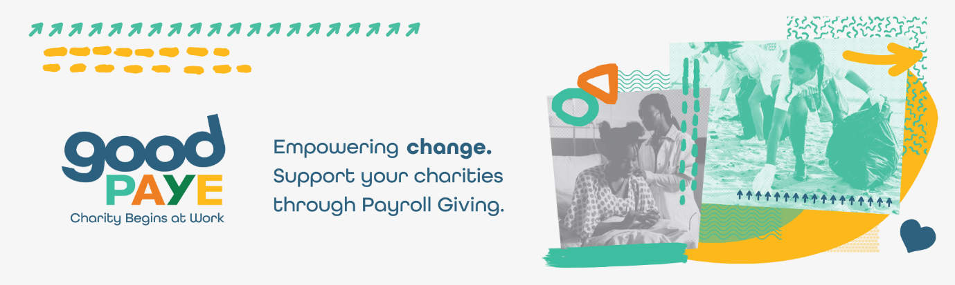
Intranet Article: Guide to Payroll Giving

We’ve partnered with GoodPAYE to empower you to change the world while you work through Payroll Giving.

What is Payroll Giving?

Payroll Giving is a way of donating to charity straight from your salary. It’s simple, it’s stress-free, and it requires no effort on your part, except for finding the charity or charities that inspire you. And the best part is, your donation is deducted automatically by us, before tax, which means the charity gets more from your donation without it costing you anymore.

How does Payroll Giving work?

For us to offer Payroll Giving to you, we’ve partnered with Payroll Giving experts, GoodPAYE. All you need to do is sign up on the GoodPAYE website (Donation form link), select the charity or charities you’d like to support and an amount you wish to give. We’ll then take care of the rest.

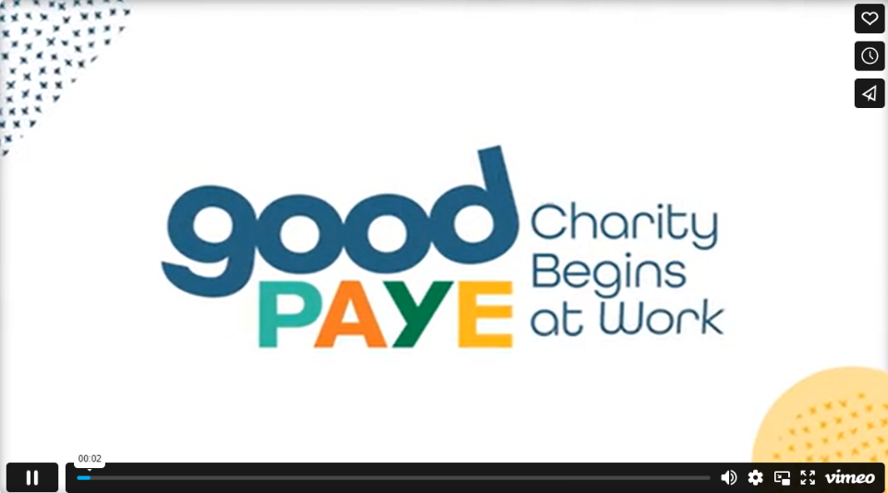

Simply:

- Visit (donation form link) and fill in the form to select your charities and your donation amounts.

- Submit the form and keep an eye out for the confirmation email sent to your inbox!

- If you’ve added your donations before our payroll cut-off date, our Payroll Team will then deduct the amount from your gross pay. You’ll see the deduction on your payslip.

- We then send the donations to GoodPAYE who then forwards them directly to your chosen charities.

- You can then log in at any time to view your donations or make any changes. Simply revisit the donation form and enter your email address to be sent a one-time link. Your Personal Data and preferences are kept completely confidential and totally secure.

Why is Payroll Giving so impactful?

Payroll Giving is the most impactful way to give to charity because of the huge tax benefits that both you and the charities receive. Let’s break it down with real numbers:

If you want to donate £10, you have two great options:

- Donate more for the same cost: You could give £12.50, £16.66, or £18.18, depending on your tax bracket, and it will still only cost you £10 in real terms.
- Donate the same but pay less: A £10 donation will actually cost you just £8, £6, or £5.50, depending on your tax rate.

Here’s how it works:

Option 1: Donate More for the Same Cost

If you want to make a £10 donation and you usually pay 20% income tax, you can set up a £12.50 Payroll Giving donation. This means £12.50 will be deducted from your gross pay and sent to your charity, but your net pay will only be reduced by £10.

For 40% taxpayers, a £16.66 Payroll Giving donation works the same way. Your charity gets £16.66, but your take-home pay is only reduced by £10. And if you pay 45% tax, you can donate £18.18 while still only being £10 out of pocket.

The charity receives the full amount directly without needing to claim back tax from HMRC, saving time and administration costs.

Option 2: Donate the Same but Pay Less

Alternatively, you can choose to donate £10 and benefit from tax savings:

- If you pay 20% income tax, it will cost you just £8.
- If you pay 40% income tax, it will cost you £6.
- If you pay 45% income tax, it will cost you just £5.50.

FAQs

- How long does it take for my donation to reach my charities?
GoodPAYE partners with hundreds of well-known charities. When an employee gives to one of GoodPAYE’s charity partners, the donation is automatically sent on one of two designated dates each month. For smaller charities outside this network, there may be a brief delay while GoodPAYE secures the necessary banking details. Once confirmed, the donation is transferred promptly on the next disbursement day.

- Is there a minimum or maximum amount I have to give?
No, there is no upper or lower limit to your donation amount. You can give as much or as little as you like to your chosen charities.

- How can I be sure that my donation will reach my chosen charity?
The payroll giving deduction will be shown on your payslip. The charity may even email or write to you to thank you for your donation and then update you regularly with information about their work. With GoodPAYE, you can log in any time to see the amount you have given to your chosen charities and check up on the status of you donations at any time.

- Can I stop giving when I want to?
Of course. You can log in to GoodPAYE at any time to stop or amend your donations. You can choose a different charity to support or change the amount you donate at any time. You are in complete control of your giving – it’s in your hands. Your giving will also automatically end If you move jobs, but you can restart in your new place of work.

- Can I give to any charity through Payroll Giving?
Yes, you can donate to any national or local charity, from poverty, to education, animals, the environment, health or anything else that interests you, even a small local charity. There are over 200,000 UK charities to choose from.

- Is there a minimum or maximum amount I have to give?
No, there is no upper or lower limit to your donation amount. You can give as much or as little as you like to your chosen charities.

- Can I stop giving when I want to?
Of course. If you leave your place of work, your giving will automatically end, and you can restart in your new place of work. You can also log in to GoodPAYE at any time to stop or amend your donations. You can choose a different charity to support or change the amount you donate at any time. You are in complete control of your giving – it’s in your hands.

- What’s the difference between Payroll Giving and Gift Aid?
Payroll Giving is taken straight from your gross pay, before income tax is deducted, so the charity does not need to claim the tax back from HMRC, saving them money and manpower in administration.

However, with Gift Aid, donations are made after income tax has been paid, so charities need to claim the tax back from HMRC.

Gift Aid is also capped at 25%, which means charities can only claim the basic rate of income tax that was paid. Therefore, it is even more efficient for higher rate taxpayers to donate through Payroll Giving than Gift Aid as charities can receive even more tax benefit without it costing the donor anymore.

- Why is Payroll Giving better than Gift Aid?
Payroll Giving allows charities to plan better and create a greater impact through their work, because donations are regular and reliable, and they don’t need to claim the tax benefit back. Instead, they get the full amount straight away, which also reduces charities admin time and costs. The tax benefit from Payroll Giving donations is also larger than Gift Aid, as it is not capped, which means that donations from those supporters who pay a higher rate of income tax are worth even more to charities.

